Lab 1 Exercises

Task # 1: Generate a script file which produces a sine wave with 2 Hz frequency.

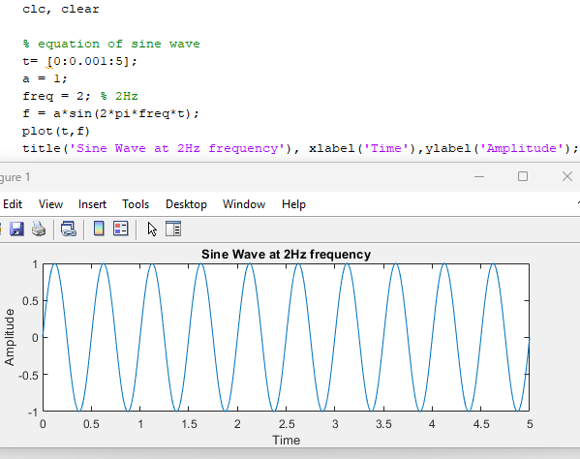

Task # 2: Generate a script file which produces a sine wave by taking frequency as an input at run time.

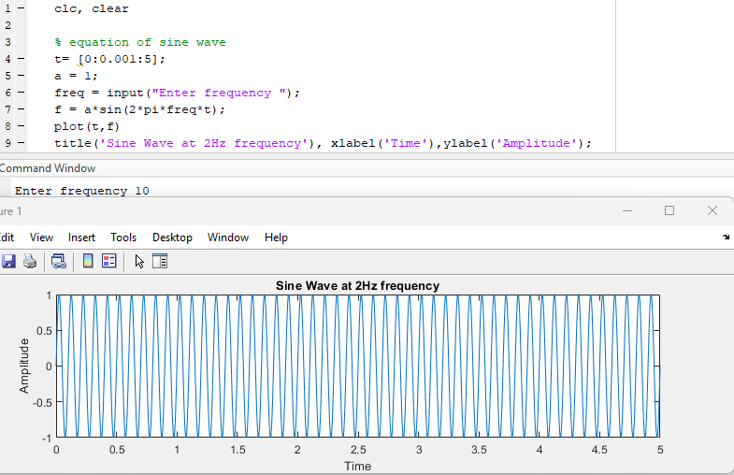

Task # 3: Generate a script file which produces a sine wave with 2Hz, 5Hz, 10Hz and 20Hz frequencies on a single figure by using subplot command. Label the subplots with the relevant frequency to distinguish the signals clearly.

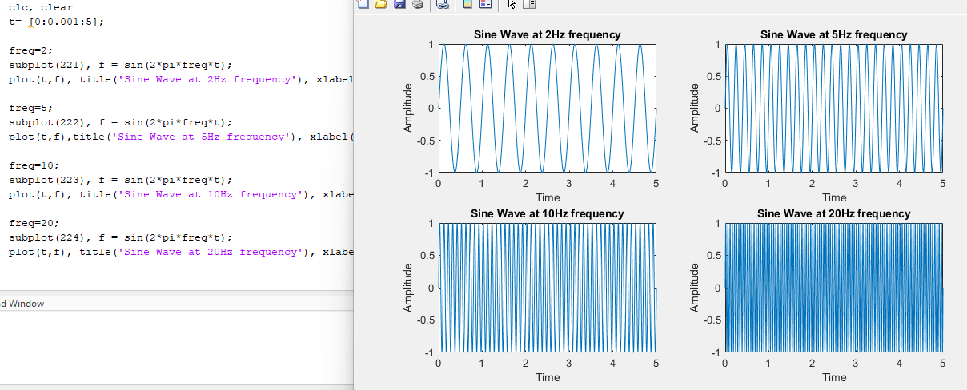

Task # 4: Implement a function as defined below, which produces a sine wave accepting time as argument.

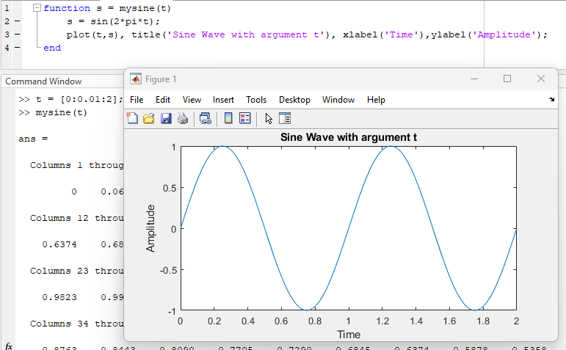

Task # 5: Generate a function which produces a sine wave by accepting frequency and amplitude as input arguments and return a plot of sine wave for the inputted parameters.

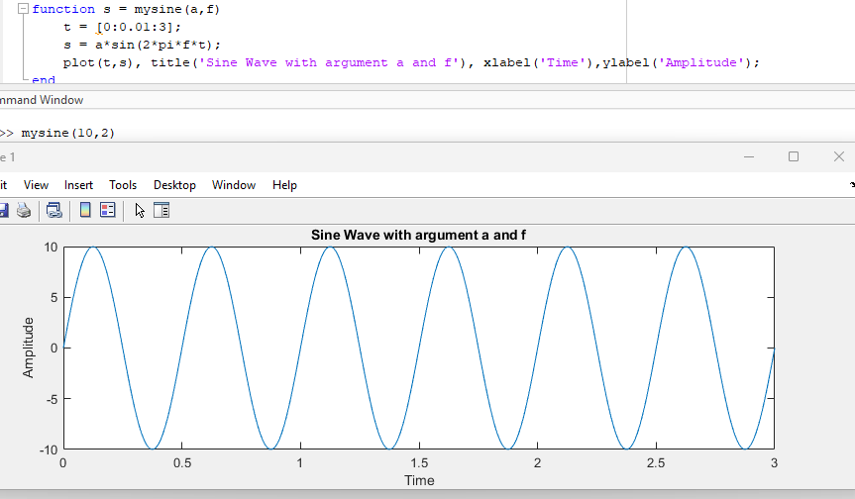

Task # 6: Repeat all above tasks by using stem command rather than plot command.

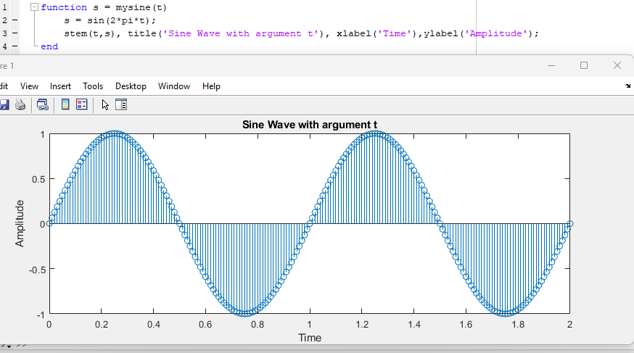
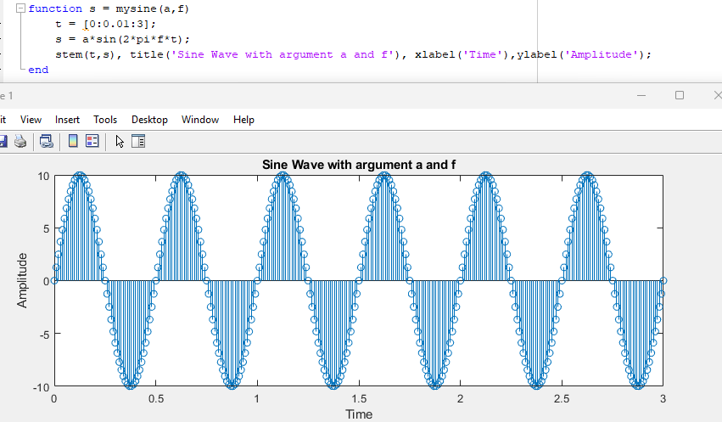

Task # 7: Write MATLAB function for plotting the 5 harmonics of a signal x(t)=cos(wt) with a fundamental frequency of f = 0.5 Hz. Take t = 0:0.01:2

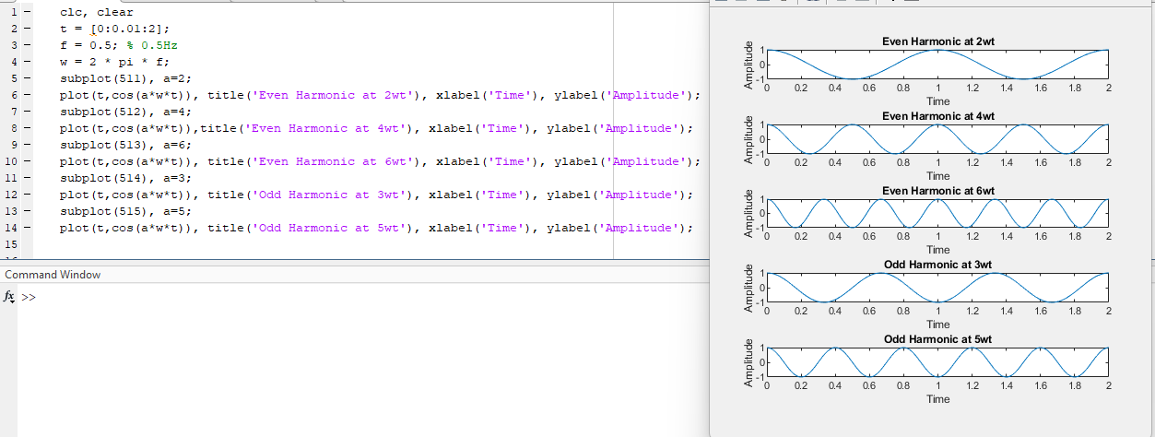

 | Harmonic #1 | Harmonic #2 | Harmonic #3 | Harmonic #4 | Harmonic #5
Time period: | 1 | 0.5 | 0.3333 | 0.6667 | 0.4
Freq: | 1 | 2 | 3 | 1.5 | 2.5

Task # 8: Try all help methods to get help of any function.
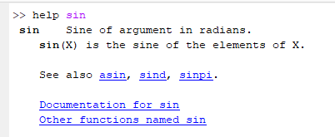

Task # 9: (a) Assign 10 samples, from 0 to 9, of time to the vector t.
(b) Assign a vector of samples without assigning it to a variable.
(c) Assign 10 samples, from 0 to 9, of time to any vector without printing it to screen.

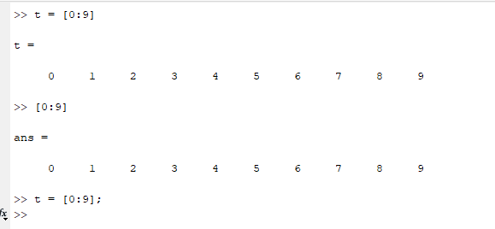

Task # 10: Investigate the difference between multiplication*and element‐wise multiplication.* of vectors/matrices.

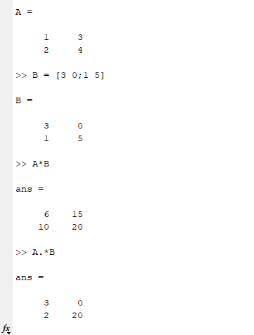

Task # 11: Generate a complex‐valued matrix a = ones (1,10)+ i* (1 : 10) and calculate the absolute square of all elements of this matrix.

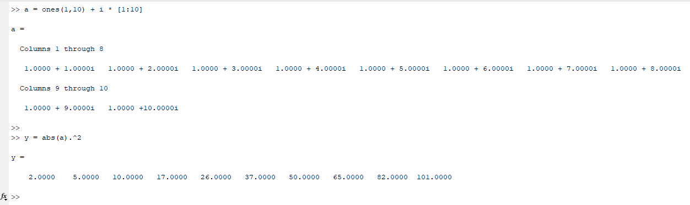
Task # 13: Use MATLAB help to get familiar with the syntax of FOR, WHILE and IF‐ELSE statement.

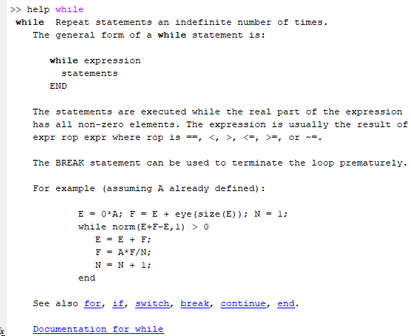
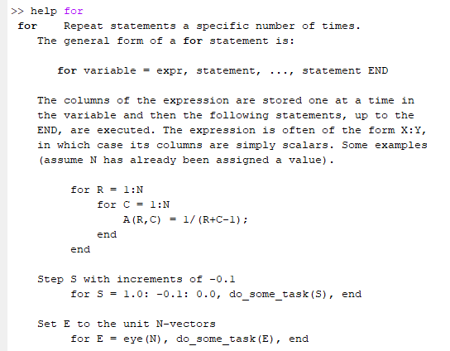

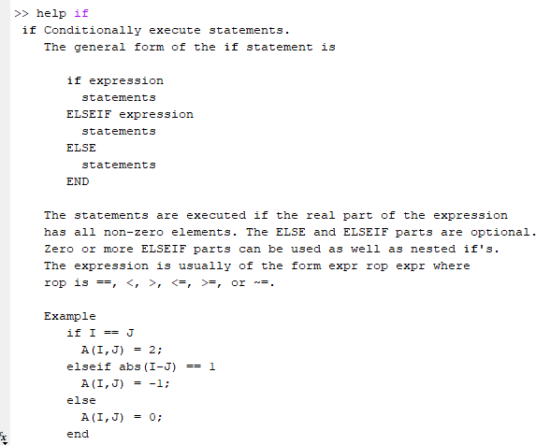

Task # 14: Use FOR loop to generate a single vector y, which is a digitized unit sine wave with ten samples per cycles, with 100 elements.
